MAT 263
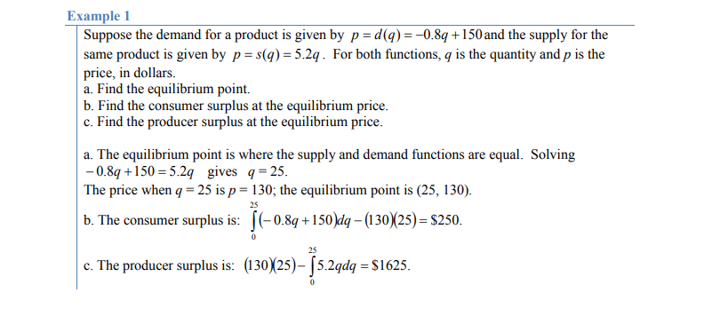
Lab 6

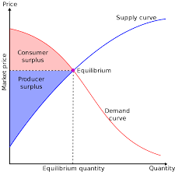

Consumer’s Surplus = $\int_{0}^{qe}{\left(D\left(x\right)-Pe\right)dx}$

Producer’s Surplus = $\int_{0}^{qe}{\left(Pe-S\left(x\right)\right)dx}$
Where D(x) is the demand curve, S(x) is the
Supply curve and (qe,Pe) is the equilibrium point.

Your problems:
- Skinner Bikes, has determined the demand function for a certain brand of mountain bike is given by: D(x) = −0.3x + 330, where x is the quantity demanded each month and D(x) is the price per bicycle in dollars. Assuming the market price for the mountain bike is $210 per bicycle, determine the consumer’s surplus.
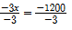
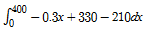
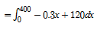
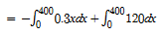
Consumer’s surplus is $24,000 each month.

- Balata Inc. a producer of golf balls, has determined that the supply function for the new Xtra golf ball is given by: S(x) = 0.24x + 3.70, where x is the number of dozens supplied each month and S(x) is the price per dozen. If the equilibrium price is $19.30 per dozen, determine the equilibrium demand, then find the producer’s surplus at equilibrium.
Put d(x) 19.30 into the demand function d(x)=0.24x+3.70
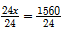
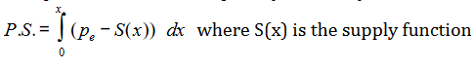
P.S =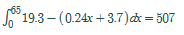
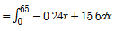

Demand of 65 dozen golf balls, gives P.S. of $507

- Office House, an office supply store, has determined that the demand for a floppy disk storage case is given by: D(x) = 30− x and the related supply function is: S(x) = $\sqrt{x}$, where x is the weekly quantity and D(x) & S(x) are in dollars per storage case. Find the equilibrium point. Determine the Consumer and Producer’s surplus at equilibrium.

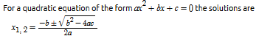
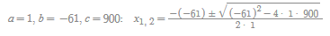
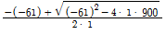
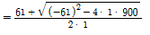
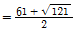
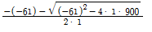
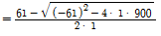
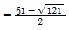
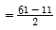
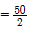
Therefore, equilibrium point (25, 5)
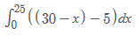
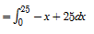
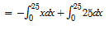
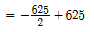
=$312.5

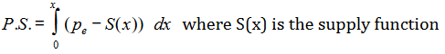
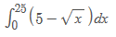
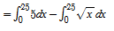
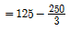
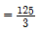
=$41.67

